**LECTURER PROFILE**

CURRICULUM VITAE

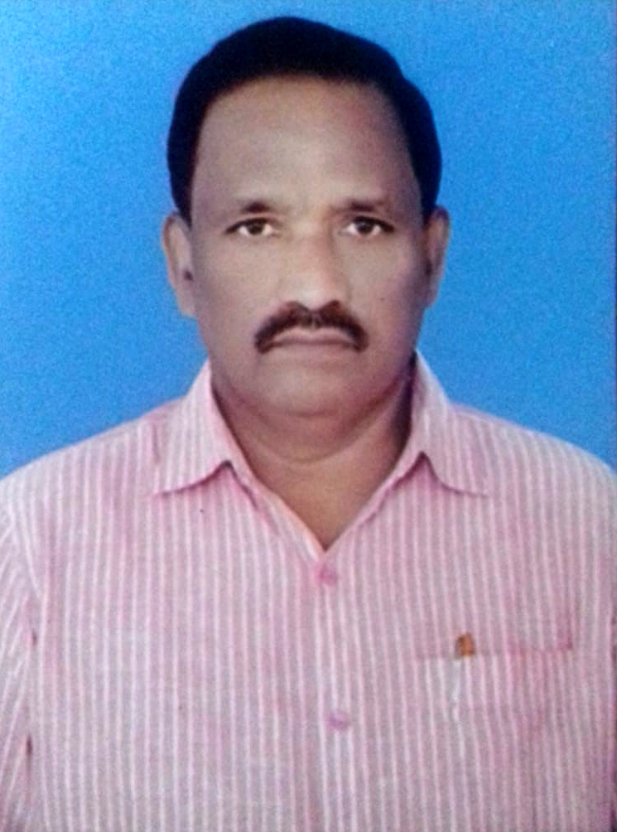

Name : AMPOLU RAMA RAO

Designation : Lecturer in Economics

Official Address : Govt. Degree College, Tekkali – 532201,

Srikakulam Dist, A.P.

Qualification : MA., B.Ed., A.P.SET

Date of Joining as a Lecturer : 21.05.2013

Address : S/o Dhillesu, Putchapadu (Vill),

G.R.Puram (Post), Mandasa (Mandal),

Srikakulam (Dist), A.P.

Cell: 9491616760, 7780668439

Email ID: [ramarao.ampolu123@gmail.com](mailto:ramarao.ampolu123@gmail.com)

Academic Qualifications:

|  |  |  |  |  |
| --- | --- | --- | --- | --- |
| Qualification | University/Board | Year of Passing | % of Marks | Class Secured |
| M.A. | Acharya Nagarjuna University | December 1988 | 65.2% | First |
| B.Ed. | Andhra University | August 1990 | 63.5% | First |
| A.P.SET | Osmania University | 27-07-2012 |  |  |

Research Experience:

Awards and Recognitions:

Membership of Professional / Academic societies:

Seminars/Conferences/Workshop attended:

|  |  |  |  |  |
| --- | --- | --- | --- | --- |
| S. No | Title of Seminar | National/International | Funded/organized by | Period |
| 1 | Demonetization Indian Banking Challenges and strategies | National Seminar | Govt. Degree College(Men), Srikakulam | 30.12.2015 |
|  |  |  |  |  |

Paper presented in National / International conference / Seminars:

|  |  |  |  |
| --- | --- | --- | --- |
| S. No | Title of Paper | Name of Seminar / Conference | Year |
| 1 | A report on conservation of Mahendragiri hills monsoon water resources and its impact on four mandals at Srikakulam Dist, A.P. | International Conference Dr.B.R.Ambedkar University, Srikakulam. | 23.02.2019 to 24.02.2019 |
| 2 | Characteristics of teaching and learning a Study on challenges | National conference Govt. College for Women (A), Srikakulam | 31.01.2020 to 01.02.2020 |
|  |  |  |  |

Faculty developments programmes attended:

|  |  |  |  |
| --- | --- | --- | --- |
| S No | Program Title | Organized / funded by | Period |
| 1 | Refresher course | UGC – Academic staff college Andhra university Visakhapatnam | 18.12.2013 to 07.01.2014 |
| 2 | One week training programme on HV&PE | UGC – Academic staff college University of Hyderabad | 17.07.2014 to 23.07.2014 |
| 3 | Orientation Course | UGC- Human resource development centre,  Andhra university, Visakhapatnam | 23.04.2015 to 20.05.2015 |
| 4 | Refresher course | UGC- Human resource Development centre,  Andhra university Visakhapatnam | 11.07.2016 to 31.07.2016 |
| 5 | Faculty Development Programme in Economics | Commissionerate of Collegiate Education, Vijayawada, A.P. | 27.07.2020 to 31.07.2020 |
| 6 | Faculty development Programme in LMS Video & Pedagogy | Commissionerate of Collegiate Education, Vijayawada, A.P. | 03.08.2020 to 07.08.2020 |
|  |  |  |  |

**Administrative/Academic contributions: Vice- Principal, Convener for House Examinations**

**Other activities and Achievements: Coordinator of DR. B. R Ambedkar Open University**

**Asst. Coordinator of School of Distance Education Andhra University**

**TEACHER ACHIEVEMENTS & PARTICIPATION:**

* Sri A.RAMARAO Lecturer in Economics participated in Andhra university national service scheme (NSS) Training and orientation centre (TOC) Visakhapatnam ORIENTATION COURSE from 2-1-2007 to 11-1-2007.
* Sri A.RAMARAO Lecturer in economics participated in the state level orientation programme in Economics conducted by Dept of intermediate education A.P. Hyderabad from 14-5-2007 to 16-5-2007 held at APCOB-ICM, RAJENDRANAGAR.
* Sri A.RAMARAO Lecturer in economics attended the orientation programme for junior Lecturers in English and Economics of Govt junior colleges in ZONE-1 Conducted by Dept. of intermediate Education Andhra Pradesh Hyderabad from 16-11-2009 to21-11-2009 at Gayatri Educational institutions, Vizianagaram.
* Sri A.RAMARAO Lecturer in Economics has qualified the APSET-2012 held on 27-07-2012.
* Sri A.RAMARAO Lecturer in Economics participated in the National service scheme (NSS) orientation course organised from 28-09-2012 to 04-10-2012 held at Dr.B.R.Ambedkar University, Etcherla, Srikakulam Dist.
* Sri.A.RAMARAO Lecturer in Economics participated in the UGC-Sponsored Refresher course organised by UGC-Academic staff college Andhra University Visakhapatnam from 18-12-2013 to 07-01-2014
* Sri.A.RAMARAO Lecturer in Economics participated in the One day regional Level science fair sponsored by Andhra Pradesh council of science and technology(APCOST) organised by Govt degree college Palakonda Srikakulam Dist. held on 25-02-2014.
* Sri.A.RAMARAO Lecturer in Economics participated in the in the One week training of trainers programme on A foundation course in Human values& professional Ethics held at UGC –Academic staff college, University of Hyderabad A.P. FROM 17-07-2014 TO23-07-2014.
* Sri.A.RAMARAO Lecturer in Economics participated in the State Level seminar on Human resource Development in Higher Education and the role of Govt Degree colleges in A.P. held on 13-12-2014.
* Sri.A.RAMARAO Lecturer in Economics participated in the in the Orientation course sponsored by UGC – Human resource Development centre Andhra university, Visakhapatnam from23-04-2015 to20-05-2015.
* Sri.A.RAMARAO Lecturer in Economics participated in the state level seminar on quality Enhancement in Govt Degree colleges- role of teachers organized by GCGTA, A.P. held at ANDHRA UNIVERSITY, Visakhapatnam on 10-10-2015.
* Sri.A.RAMARAO Lecturer in Economics participated in the Inter Disciplinary Refresher course in the subject Education Technology organised by UGC-Human Resource Development centre, Andhra university ,Visakhapatnam from11-07-2016 to 31-07-2015.
* Sri.A.RAMARAO Lecturer in Economics participated in the one day National seminar on Demonetisation Indian Banking, challenges and strategies organised by Govt Degree College (Men) Srikakulam held on 30-12-2015.
* Sri.A.RAMARAO Lecturer in Economics participated as member in the workshop organised by the Dept of chemistry, Govt Degree College, Tekkali on 21-11-2017.
* Sri .A.RAMARAO Lecturer in Economics paper presented on A report on conservation of Mahendragiri hills monsoon water resources and its impact on four mandals at Srikakulam Dist A.P. in the international conference on water, sanitation and Hygiene-2019(WASH-2019) organised byDr.B.R.Ambedkar university Srikakulam A.P from 23-02-2019 to 24-02-2019.
* Sri A.RAMARAO Lecturer in Economics presented paper on characteristics of teaching and learning A Study on challenges in two day National conference on future challenges Higher Education institutes in Assessment Accreditation and Ranking Framework Methodologies (FCHIARF-2020) organised by Govt college for Women(A) Srikakulam from 31-01-2020 to 01-02-2020.
* Sri.A.RAMARAO Lecturer in Economics participated in 5 day faculty development programme in Economics organised by Commissionerate of collegiate Education, Vijayawada A.P. from 27-07-2020 to 31-07-2020.
* Sri.A.RAMARAO Lecturer in Economics participated 5 day faculty Development programme in LMS Video & Pedagogy organised by commissionerate of collegiate Education, Vijayawada, A.P. from03-08-2020 to 07-08-2020.
  + **Research Activity**
* The departmental faculty members regularly attend National, International Conferences /seminars and workshops on economic studies.